**INVENTORY STORE MANAGEMENT SYSTEM**

Project submitted to the

SRM University – AP, Andhra Pradesh

for the partial fulfillment of the requirements to award the degree of

**Bachelor of Technology/Master of Technology**

In

**Computer Science and Engineering**

**School of Engineering and Sciences**

Submitted by

**K . Jaya Prakash**

**(AP20110010403)**

Under the Guidance of

**Prof. Dr Rajiv Senapati**

Department of Computer science Engineering

**SRM University–AP**

**Neerukonda, Mangalagiri, Guntur**

**Andhra Pradesh – 522 240**

**[December, 2022]**

# Certificate

Date: 15-Dec-22

This is to certify that the work present in this Project entitled “**INVENTORY STORE MANAGEMENT SYSTEM**” has been carried out by **K. Jaya Prakash** under my/our supervision. The work is genuine, original, and suitable for submission to the SRM University – AP for the award of Bachelor of Technology/Master of Technology in **School of Engineering and Sciences**.

**Supervisor**

(Signature)

Prof. / Dr. [Name]

Designation,

Affiliation.

**Co-supervisor**

(Signature)

Prof. / Dr. [Name]

Designation,

Affiliation.

# Acknowledgements

We thank **Dr**. **Rajiv** **Senapati**, our professor in charge, for the help and direction finishing the project on the subject inventory store management system. It was a fantastic learning opportunity. This subject has given me an opportunity to explore the field I always have been curious about. Your insightful counsel and recommendations were quite beneficial to me as I finished the assignment. I will always be grateful to you for this.

# Table of Contents

Certificate i

Acknowledgements iii

Table of Contents iv

Abstract vi

1. Introduction 1

2. Methodology 3

3. List of Entities : 3

4. ER MODEL: 6

5. ER MODEL TO RELATIONAL MODEL 7

6. Normalization : 9

7. SQL Code for the project: 19

8. SQL QUERIES : 32

9. Concluding Remarks 36

10. References : 37

# Abstract

Data needs to be stored in an organized way so that it is easy to use and manipulate the information. This Project talks about inventory store management system which is an combination of (software and hardware) and process and procedures that oversee the monitoring and maintenance of stocked products, which includes management of raw materials, components and finished products. This system can be widely used by normal shops and departmental stores for keeping proper track of stock, it contains manager details, customer details etc. Checking requirements, finding all entities and their properties, ER diagram, converting ER to relational model, Normalizing, and SQL code are the steps followed. The main theme is to decrease the redundancy and inconsistency of the data.

# Introduction

There are various ways to store and retrieve the data. Older versions like using files for data organizing have many issues and take more manpower and time. Data redundancy, Data inconsistency, Data isolation, Atomicity, Concurrent access, Security are the few tasks which become an anomaly by using files. Database management system (DBMS) helps to hold all above issues.

Store management system is one of the applications where maintaining a database is required. In this report the simple requirements were considered. This database system stores the data about the availability of the products, information regarding sale statistics, details of manager so that customers can contact with them easily.

# Methodology

**Step 1 :**

# List of Entities :

1.Manager

2.Supplyers

3.Products

4.Store

5.Workers

6.Billing

7.Sales

8.Customer

9.Payment

10.Tax



**Step 2:**

**List of attributes :**

1. Manager(manager_id , manager_name , manager_Qualification , manager_ContactNumber, manager_dateofbirth, , manager_gender, manager_address).
2. Supplyer(supplyer_id , supplyer_name, supplyer_address, supplyer_contactnumber).
3. Products(product_id , product_name , product_type , product_cost , product_discription).
4. Store(store_id , store_name , store_contactnumber , store_address).
5. Workers(worker_id , worker_name , worker_type , worker_salary , worker_contact , worker_gender).
6. Billing(billing_id , billing_date , billing_amount).
7. Sales(sales_id , sales_cost , sales_discription).
8. Customer(customer_id , customer_name , customer_address , customer_contact , customer_email_id).
9. Payment(payment_id , payment_date , payment_amount , payment_type , payment_status).
10. Tax(tax_id , tax_amount , tax_type).

**Step 3 :**

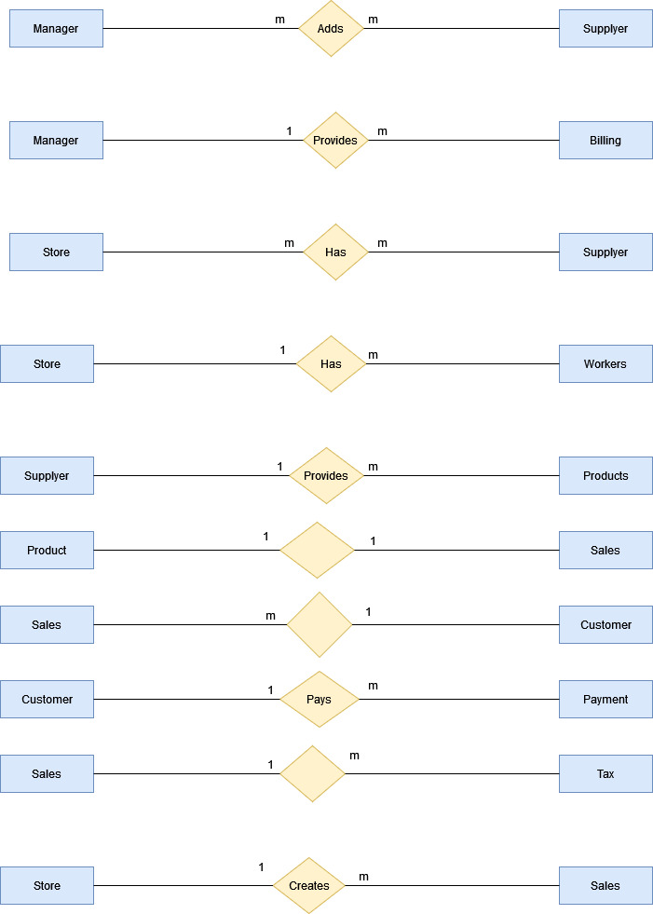

# ER MODEL:

**ER Diagram:**

# 

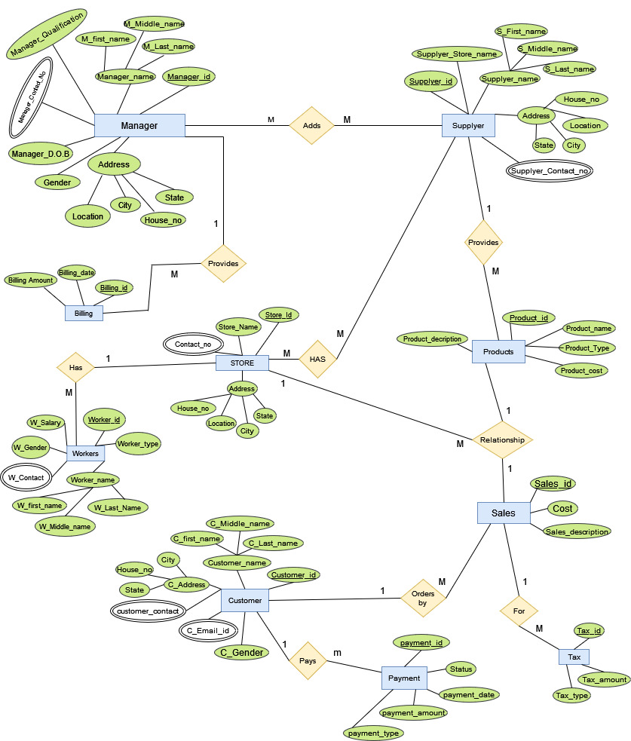

# ER MODEL TO RELATIONAL MODEL

**RELATIONAL MODEL :** Data is represented as relation (or table) which consists of rows and columns.

Below are the rules used for conversion of ER model to Relational model

1. An entity in the ER model is represented by a relational table in the relational model.

2. All the attributes of the ER model are represented in different columns as an attribute.

3. Primary key attribute of the ER model is represented as the primary key in the relational model.

4. Composite key of the ER model is split in different columns in the relational model.

5. Derived attributes must be dropped in relational models.

6. Multi valued attributes need to be kept separate in a new table.

7. If the relationship between two entities is 1:1 then the primary key of one relation becomes foreign key in another relation.

8. If the relationship between entities is 1:M or M:1 then the primary key attribute of one-sided relations becomes a foreign key in many-sided relations.

9. If the relationship between entities is M:M then a new table needs to be created to represent that relation, where the new relation will have the primary key of both relations as the foreign keys.

**Relational model:**

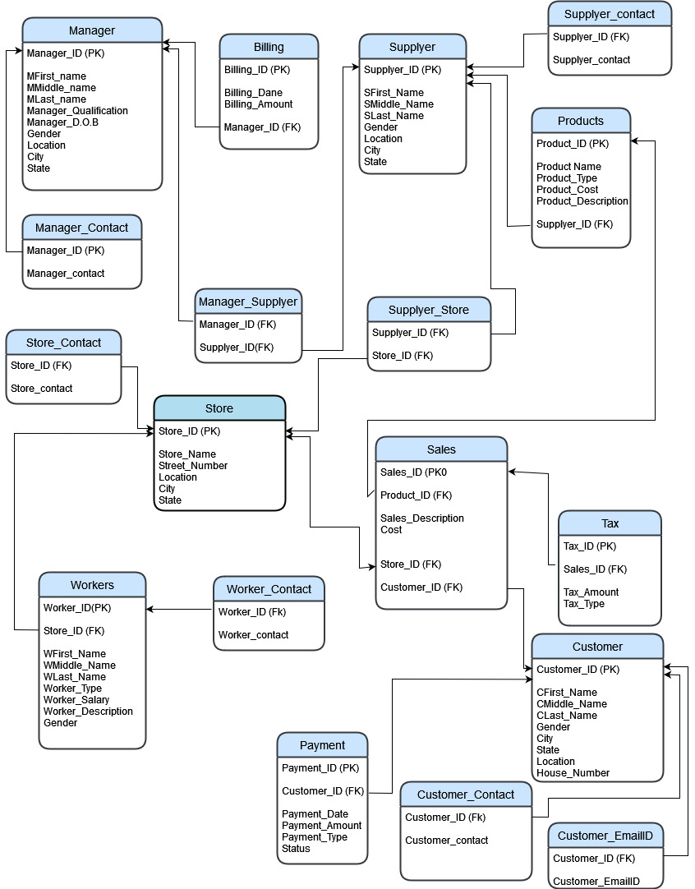

# Normalization :

Normalization is a process of analyzing and decomposing the complex relation which satisfies some constraint to form a simple relation.

There are 5 Normal forms:

1. First Normal Form (1NF)

2. Second Normal Form (2NF)

3. Third Normal Form (3NF) or Boyes Cord Normal Form (BCNF)

4. Fourth Normal Form (4NF)

5. Fifth Normal Form (5F) or Project Join Normal Form (PJNF)

**Manager Table:**

Attributes :

Manager-ID, Mfirst_name, Mmiddle_name, Mlast-name, Manager_qualification, Manager-DOB, House-number, Location, City, State.

functional Dependencies:-

Manager – ID 🡪 Mfirst_name

Manager ID 🡪 Mmiddle_name

Manager ID 🡪 Mlast_name

Manager ID 🡪 Manager_qualification

Manager-ID 🡪 Manager_D.O.B

Manager-ID 🡪 Location

Manager-ID 🡪 City

Manager-ID 🡪 State

Manager-ID 🡪 Gender

Primary_Key: Manager_ID

**First Normal Form(1NF):**

CONDITION: If a relation is said to be in 1NF only if it has no non atomic attributes in it.

The table is already in First Normal Form because there are no non atomic attributes present in it.

**Second Normal Form(2NF):**

If a relation is said to be in 2NF then the relation should be in 1NF and should satisfy any one of the below conditions.

CONDITIONS: 1. If the primary_key consists of only one attribute.

2.If there exists no non key attributes.

3. Every non key attribute present in the relation should be fully functionally dependent on the full set of the primary_key.

The table is already in 2NF because it is 1NF and satisfies the first condition of the second normal form.

**Third Normal Form(3NF):**

CONDITION: If a relation is said to be in 3NF only if the relation is in 1NF, 2NF & it has no transitive functional dependency in it.

The table is already in 3NF because it is in 1NF, 2NF and there is no transitive functional dependency in the table.

**Boyce Codd Normal Form(BCNF):**

CONDITION: If a relation is said to be in BCNF only if it is in 1NF, 2NF, 3NF and satisfies any one of the below conditions.

1. X 🡪 Y, Y be a subset of X
2. X is a Super Key

The table is already in BCNF because it is in 1NF, 2NF, 3NF & it satisfies the first condition of BCNF.

**Fourth Normal Form(4NF):**

If a relation is said to be in fourth normal form(4NF) only if it has no multivalued dependencies.

The table is already in 4NF because it has no multivalued dependencies.

**Manager_Contact Table:**

Attributes:

Manager_ID, Manager_contact

Functional Dependencies:

Manager_ID 🡪 Manager_Contact

Primary & Foreign Key: Manager_ID

**First Normal Form(1NF):**

The table is already in 1NF because it has no non atomic attributes present in it.

**Second Normal Form(2NF):**

The table is already in 2NF because it is in 1NF & satisfies the third condition of 2NF.

**Third Normal Form(3NF):**

The table is already in 3NF because the table is in 1NF, 2NF and it does not have any transitive functional dependency int it.

**Boyce Codd Normal Form(BCNF):**

The table is already in BCNF because the table is in 1NF, 2NF, 3NF & it satisfies the first condition of the Boyce Codd Normal Form.

**Fourth Normal Form(4NF):**

The table is already in 4NF because the table has no multivalued dependencies in it.

**Products Table:**

Attributes:

Product_ID, Product_Name , Product_Type, Product_cost, Product_description

Functional Dependencies:

Product_ID 🡪 Product_name

Product_ID 🡪 Product_Type

Product_ID 🡪 Product_cost

Product_ID 🡪 Product_description

Primary Key: Product_iD

**First Normal Form(1NF):**

The table is already in 1NF because the table has no non atomic attributes present in it.

**Second Normal Form(2NF):**

The table is already in 2NF because the table is in 1NF & has no partial functional dependencies in it.

**Third Normal Form(3NF):**

The table is already in 3NF because the table is in 1NF, 2NF & has no transitive functional dependency among the attributes.

**Fourth Normal Form(4NF):**

The table is already in 4NF because it has no multivalued dependency in it.

**Sales Table:**

Attributes:

Sales_ID, cost, Sales_description

Functional Dependencies:

Sales_ID 🡪 cost

Sales_ID 🡪 Sales_description

Primary Key: Sales_ID

**First Normal Form(1NF):**

The table is already in 1NF because the table has no non atomic attributes in it.

**Second Normal Form(2NF):**

The table is already in 2NF because the table is in 1NF & has only one Primary Key in it which satisfies the first condition of 2NF.

**Third Normal Form(3NF):**

The table is already in 3NF because the table is in 1NF, 2NF & has no transitive functional dependency among the attributes.

**Fourth Normal Form(4NF):**

The table is already in 4NF because it has no multivalued dependency in it.

**Store Table:**

Attributes:

Store_ID, Store_Name, Street_name , Location, city, state

Functional Dependencies:  
Store_ID 🡪 Store_Name

Store_ID 🡪 Street_name

Store_ID 🡪 Location

Store_ID 🡪 city

Store_ID 🡪 State

Primary Key: Showroom_ID

**First Normal Form(1NF):**

The table is already in 1NF because the table has no non atomic attributes in it.

**Second Normal Form(2NF):**

The table is already in 2NF because the table is in 1NF & has no partial dependencies in it which satisfies the third condition of 2NF.

**Third Normal Form(3NF):**

The table is already in 3NF because the table is in 1NF, 2NF & has no transitive functional dependency among the attributes.

**Fourth Normal Form(4NF):**

The table is already in 4NF because it has no multivalued dependency in it.

**Worker_Table:**

Attributes:

Worker_ID, Wfirst_name, Wmiddle_name, Wlast_name, Worker_type, Worker_salary, Worker_description, Gender.

Worker_ID 🡪 Wfirst_name

Worker_ID 🡪 Wmiddle_name

Worker _ID 🡪 Wlast_name

Worker _ID 🡪 Worker_type

Worker _ID 🡪 Worker_salary

Worker _ID 🡪 Worker_description

Worker _ID 🡪 Gender

Primary Key: Worker_ID

**First Normal Form(1NF):**

The table is already in 1NF because the table has no non atomic attributes in it.

**Second Normal Form(2NF):**

The table is already in 2NF because the table is in 1NF & has only one primary key in it which satisfies the first condition of 2NF.

**Third Normal Form(3NF):**

The table is already in 3NF because the table is in 1NF, 2NF & has no transitive functional dependency among the attributes.

**Fourth Normal Form(4NF):**

The table is already in 4NF because it has no multivalued dependency in it.

**Payment Table:**

Attributes:

Payment_ ID, Payment_ date, Payment_ Amount, Payment_ type, Status

Functional Dependencies:

Payment _ID 🡪 Payment _date

Payment _ID 🡪 Payment _Amount

Payment _ID 🡪 Payment _type

Payment _ID 🡪 Status

Primary Key: Payment _ID

**First Normal Form(1NF):**

The table is already in 1NF because the table has no non atomic attributes in it.

**Second Normal Form(2NF):**

The table is already in 2NF because the table is in 1NF & has only one primary key in it which satisfies the first condition of 2NF.

**Third Normal Form(3NF):**

The table is already in 3NF because the table is in 1NF, 2NF & has no transitive functional dependency among the attributes.

**Fourth Normal Form(4NF):**

The table is already in 4NF because it has no multivalued dependency in it.

**Customer Table:**

Attributes:

Customer_ID, Cfirst_ name, Cmiddle_ name, Clast_name, Location, city, state.

Functional Dependencies:

Customer _ID 🡪 Cfirst_ name

Customer _ID 🡪 Cmiddle_ name

Customer _ID 🡪 Clast_name

Customer _ID 🡪 Location

Customer _ID 🡪 city

Customer _ID 🡪 State

Primary Key: Customer _ID

**First Normal Form(1NF):**

The table is already in 1NF because the table has no non atomic attributes in it.

**Second Normal Form(2NF):**

The table is already in 2NF because the table is in 1NF & has only one primary key in it which satisfies the first condition of 2NF.

**Third Normal Form(3NF):**

The table is already in 3NF because the table is in 1NF, 2NF & has no transitive functional dependency among the attributes.

**Fourth Normal Form(4NF):**

The table is already in 4NF because it has no multivalued dependency in it.

**Tax Table:**

Attributes:

Tax_ ID, Tax_ Amount, Tax_ Type

Functional Dependencies:

Tax _ID 🡪 Tax _Amount

Tax _ID 🡪 Tax _Type

Primary Key: Payment _ID

**First Normal Form(1NF):**

The table is already in 1NF because the table has no non atomic attributes in it.

**Second Normal Form(2NF):**

The table is already in 2NF because the table is in 1NF & has only one primary key in it which satisfies the first condition of 2NF.

**Third Normal Form(3NF):**

The table is already in 3NF because the table is in 1NF, 2NF & has no transitive functional dependency among the attributes.

**Fourth Normal Form(4NF):**

The table is already in 4NF because it has no multivalued dependency in it.

**Multivalued Tables:**

**First Normal Form(1NF):**

All the multivalued tables are already in 1NF because all the tables has no non atomic attributes in them.

**Second Normal Form(2NF):**

All the multivalued tables are already in 2NF because all the tables are in 1NF & has no partial dependencies in them which satisfies the first condition of 2NF.

**Third Normal Form(3NF):**

All the tables are already in 3NF because the tables are in 1NF, 2NF & has no transitive functional dependency among the attributes in the multivalued tables.

**Fourth Normal Form(4NF):**

All the tables are already in 4NF because the tables has no multivalued dependency in them.

# SQL Code for the project:

create database project;

use project;

-----------------------------#CREATINGTABLES:-------------------------------------

#1.MANAGER TABLE....

create table manager (

Manager_id int primary key,

Mfirst_name varchar(20),

Mmiddle_name varchar(20),

Mlast_name varchar(20),

Manager_Qualification varchar(20),

Manager_DOB date,

Gender varchar(15),

Location varchar(20),

city varchar(20),

State varchar(20)

);

create table Billing_details (

Billing_id int primary key,

Billing_date date,

Billing_amount int,

Manager_id int references manager(Manager_id)

);

create table manager_contact (

Manager_id int references manager(Manager_id),

Manager_contact int

);

create table supplyer (

Supplyer_id int primary key,

Supplyer_store_name varchar(20),

Supplyer_first_name varchar(20),

Supplyer_middle_name varchar(20),

Supplyer_last_name varchar(20),

Supplyer_location varchar(20),

city varchar(20),

State varchar(20),

Supplyer_Gender varchar(10)

);

create table Supplyer_contact (

Supplyer_id int references supplyer(Supplyer_id),

Supplyer_contact int

);

create table manager_supplyer (

Manager_id int references manager(Manager_id),

Supplyer_id int references supplyer(Supplyer_id)

);

create table products (

Product_id int primary key,

Product_name varchar(20),

Product_type varchar(20),

Product_cost varchar(20),

Product_discription varchar(20),

Supplyer_id int references supplyer(Supplyer_id)

);

create table store (

Store_id int primary key,

Store_name varchar(20),

Store_street_name varchar(20),

location varchar(20),

city varchar(20),

state varchar(20)

);

create table store_contact (

Store_id int references store(Store_id),

Store_contact_nummber int

);

create table Supplyer_store (

Supplyer_id int references supplyer(Supplyer_id),

Store_id int references store(Store_id)

);

create table workers

(

Workers_id int primary key,

Workers_first_name varchar(20),

Workers_middle_name varchar(20),

Workers_last_name varchar(20),

Store_id int references store(Store_id),

Workers_type varchar(20),

Workers_salary int,

Workers_discription varchar(20)

);

create table workers_contact

(

Workers_id int references workers(Workers_id),

Workers_contact int

);

create table customer

(

Customer_id int primary key,

Customer_first_name varchar(20),

Customer_middle_name varchar(20),

Customer_last_name varchar(20),

Customer_street_name varchar(20),

location varchar(20),

city varchar(20),

state varchar(20),

Customer_gender varchar(10)

);

create table sales

(

Sales_id int primary key,

Product_id int references products(Product_id),

cost int ,

Sales_discription varchar(20),

Store_id int references store(Store_id),

Customer_id int references customer(Customer_id)

);

create table tax

(

Tax_id int primary key,

Tax_amount int ,

Tax_type varchar(20),

Sales_id int references sales(Sales_id)

);

create table customer_email

(

Customer_id int references customer(Customer_id),

email_id varchar(20)

);

create table customer_contact

(

Customer_id int references customer(Customer_id),

Customer_contact_number int

);

create table payment

(

Payment_id int primary key ,

Customer_id int references customer(Customer_id) ,

Payment_date date ,

Payment_amount int ,

Payment_type varchar(20) ,

Payment_status varchar(20)

);

insert into manager values(1,'kadiyala','jaya','prakash','PHD','2003-06-14','male','gannavaram','vijayawada','AP');

select*from manager;



insert into Billing_details values(11,'2022-11-27','56000',2);

insert into Billing_details values(16,'2005-04-27','100000',1);

insert into Billing_details values(120,'2000-12-11','56000',4);

insert into Billing_details values(17,'2011-02-01','4326000',3);

select*from Billing_details;

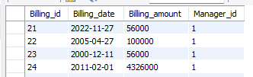

insert into manager_contact values(1,'90146447');

select*from manager_contact;



insert into supplyer values(1,'ravi_store','komminani','jagadeesh','chowdary','kasarapalli','vijayawada','AP','male');

insert into supplyer values(2,'jagu_store','komminani','ravi','teja','nidamaru','guntur','AP','male');

insert into supplyer values(3,'narayana_store','kadiyala','narayana','murthy','koragalu','vijayawada','AP','male');

insert into supplyer values(4,'chandu_store','komminani','chandra','shakar','kasarapalli','vijayawada','AP','male');

select*from supplyer;

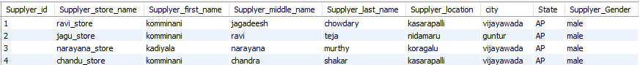

insert into Supplyer_contact values(1,'123456789');

insert into Supplyer_contact values(2,'098765432');

insert into Supplyer_contact values(3,'756484657');

insert into Supplyer_contact values(4,'999999999');

select*from Supplyer_contact;

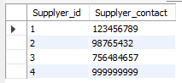

insert into manager_supplyer values(1,1);

select *from manager_supplyer;

insert into manager_supplyer values(1,4);

insert into manager_supplyer values(4,3);

insert into manager_supplyer values(22,7);

insert into products values(101,'santoor','soap','100','itwillcleanourbody',1);

insert into products values(102,'samsunggalaxyA21S','mobile','15000','used to talk',2);

insert into products values(103,'colgate','paste','80','usedto clean teeth',3);

insert into products values(104,'crocks','footwear','1500','protect our foot',4);

select*from products;

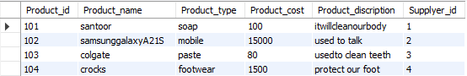

insert into store values(1,'jaya_store','royalstreet','gannavaram','vijayawada','AP');

insert into store values(2,'chandu_store','shoppingstreet','mangalagiri','gunture','AP');

insert into store values(3,'srujana_store','cinemastreet','jalandhar','patiala','punjab');

insert into store values(4,'nithin_store','changestreet','ludhiana','bathinda','bihar');

select * from store;

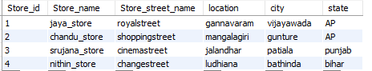

insert into store_contact values(1,'878799098');

insert into store_contact values(2,'656567743');

insert into store_contact values(3,'949083829');

insert into store_contact values(4,'888776654');

select * from store_contact;

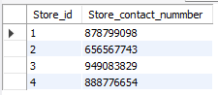

insert into Supplyer_store values(1,1001);

insert into Supplyer_store values(2,1002);

insert into Supplyer_store values(4,203);

insert into Supplyer_store values (3,303);

select*from Supplyer_store;

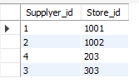

insert into workers values(10,'nikith','sai','reddy',1,'phone_display','20000','whoexplainsphones');

insert into workers values(11,'mahamad','ashmi','irfan',2,'cashier','50000','whocollectscash');

insert into workers values(12,'boddu','lakshmi','sndeep',3,'cleaner','5000','whocleansfloor');

insert into workers values(13,'sai','vishnu','vrdhan',4,'securitygard','10000','protectfromthieves');

select * from workers;

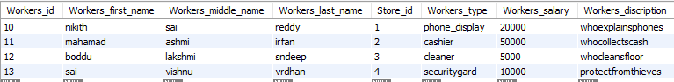

insert into workers_contact values(10,'849384848');

insert into workers_contact values(11,'545454544');

insert into workers_contact values(12,'500004544');

insert into workers_contact values(13,'545212124');

select * from workers_contact;

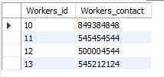

insert into customer values(1,'shaik','azaj','uddin','marketstreet','mangalagiri','gunture','AP','male');

insert into customer values(2,'mahesh','kumar','reddy','golastreet','jagadiriguta','hydrabad','telangana','male');

insert into customer values(3,'valabanani','srujana','sri','katuru','govindrapata','kammam','telangana','female');

insert into customer values(4,'puttaparti','sai','venkat','chittoor','palamneru','hanumukonda','gujarath','male');

select * from customer;



insert into sales values(110,101,'500','good',2,1);

insert into sales values(111,103,'4000','best',4,2);

insert into sales values(112,102,'1000','average',3,3);

insert into sales values(113,103,'6000','good',1,4);

select * from sales;

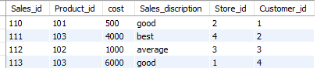

insert into tax values(1000,'250','retailtax',110);

insert into tax values(1001,'840','wholesaletax',111);

insert into tax values(1002,'110','valueaddedtax',112);

insert into tax values(1003,'504','manufacturerstax',113);

select*from tax;

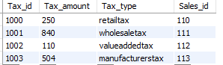

insert into customer_email values(1,'jaya11@gmail.com');

insert into customer_email values(2,'sai@gmail.com');

insert into customer_email values(3,'venkat@gmail.com');

insert into customer_email values(4,'prakash@gmail.com');

select* from customer_email;

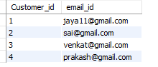

insert into customer_contact values(1,'909090909');

insert into customer_contact values(2,'666666666');

insert into customer_contact values(3,'888888888');

insert into customer_contact values(4,'111111111');

select*from customer_contact ;

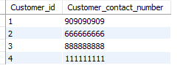

insert into payment values(100001,2,'2022-11-20','10000','cardpayment','success');

insert into payment values(100002,1,'2022-10-11','5000','onlinepayment','success');

insert into payment values(100003,3,'2022-09-23','2000','cashpayment','success');

insert into payment values(100004,4,'2022-11-27','5000','onlinepayment','success');

select * from payment;

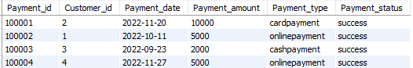

# SQL QUERIES :

-------------------------------------------------------------------------#QUERIES-----------------------------------------------------

select all Product_name

from products

where Product_type ='soap';



select all Product_name

from products

where Product_type ='mobile';



select customer.Customer_middle_name

from customer,sales

where

sales.Customer_id=customer.Customer_id;

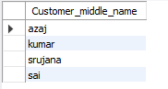

select customer.Customer_middle_name

from customer,sales

where

sales.Customer_id=customer.Customer_id and

State='telangana';

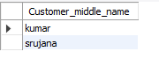

select Product_name, max(Product_cost)

from products;

select Product_name, min(Product_cost)

from products;

select Product_name,Customer_middle_name,Product_cost

from products,customer;

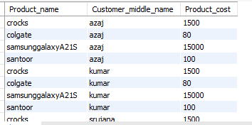

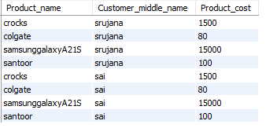

select Sales_discription,Product_name,Customer_middle_name,Product_cost

from sales,products,customer

where sales.Product_id=products.Product_id and

sales.Customer_id=customer.Customer_id;

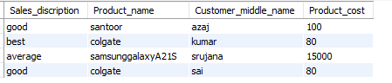

select Sales_discription,Product_name,Customer_middle_name,Product_cost

from sales,products,customer;

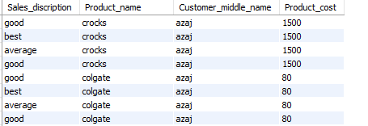

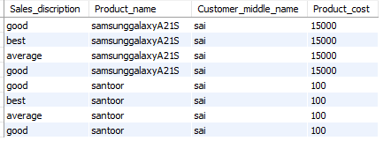

# Concluding Remarks

A description of the background and context of the project and its relation to work already done in the area. Made statement of the aims and objectives of the project. The description of Purpose, Scope, and applicability. I have defined the problem on which I had worked in the project. I have described the requirement Specifications of the system and the actions that can be done on these things. I had understood the problem domain and produce a model of the system, which describes operations that can be performed on the system. I have included the features and operations in detail, including screen layouts.

# Future work

Today India is flooded with various super markets and stores for customers to buy In the last couple of years the growth of inventory store management system has been phenomenal as more store managers and customers started discovering the benefits of using this platform. There is enough scope for inventory store management system in the future if they understand the Indian shoppers psyche and cater to their needs. So, I would like to develop a webpage for this project in the coming days.

# References :

1. <https://github.com/topics/inventory-management-system>
2. <https://www.geeksforgeeks.org/dbms/>
3. <https://www.unleashedsoftware.com/inventory-management-guide/inventory-management-systems>
4. <https://youtu.be/4eSjYd68AI0>
5. <https://www.camcode.com/blog/what-is-an-inventory-management-system/>